July 30th. 2006
Leonie, Gavin and Nadine
Well, first of all, its ‘Happy Birthday’ to Leonie this time for next Friday. Take your pick of birthday cards! (Actually, I have used these cars before but I still think they are quite good.)

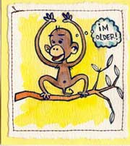


I went the hospital on Thursday morning for the minor operation to remove the suspected tumour at the bottom of one leg. They knew about this when all the others sites were removed but decided to leave it. I wish they had removed it then. Apart from wasting half a day, it means I will not be able to swim for a while. There were about 10 people there all having similar minor operations. Only took about 10 minutes for the actual excision. While there, they provided us with lunch. There was no choice, and I suppose because I am a westerner, I got one sandwich instead of a boxes of rice, vegetables and soup which I would have preferred. The charges were also different. It is regarded as an admission, so there was the charge for admission ($50) and the charge for one day ($100).

Because of the operation, I decided to have three swims last week. Did a total of 8.4 km. On the Wednesday, I swam 4 km, which may be a distance record for me. The water temperature had cooled down to 32⁰C (!!) and I just kept on going and going. On Thursday morning, I went across to the pool at 7 am to swim a few lengths before going to the hospital. However, they would not open it due to a thunderstorm and heavy rain warning. I did not do any exercise in the afternoon but was back in the gym again on Friday but just for a light workout – I think the swim had exhausted me a bit.
The tri-nations match yesterday was NZ against Australia. The game also doubled as a Bledisloe Cup match (just the NZ-Australia competition). NZ won the test, just, 13 – 9. There was only one try, scored by Joe Rokocoko (shown).
Gavin – the socks and skin crack cream you sent arrived. Thanks. The first thing I did, as you told me to do, was to cut my toenails. The socks look nice. I do have a problem with toes and socks, as my big toes are rather long and tend to push through the ends of the socks. I do not know if the socks can be used as sports socks or not; they come up to ankle height, which is about right. Still, I may wear them just for ‘best.’

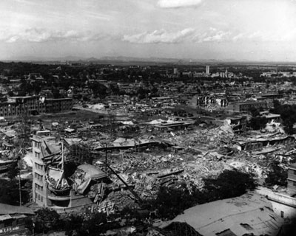
Last Friday was the 30th anniversary of the Tang Shan earthquake in China, in which the city was levelled by a 7.8 magnitude earthquake and about 250 000 people were killed (though some experts believe the real figure was 3 times that). Because of China’s control over the press, and because Chairman Mao was on his deathbed, the rest of the world got little news of the tragedy.
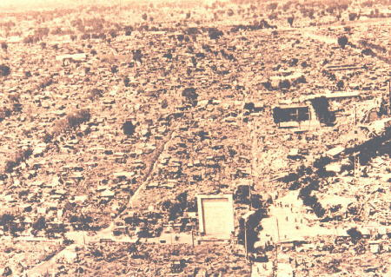
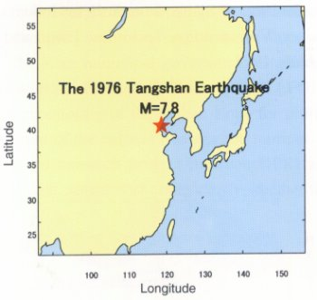
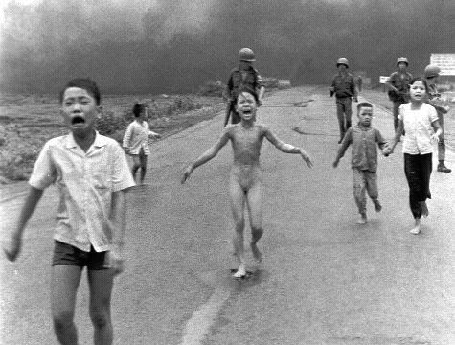
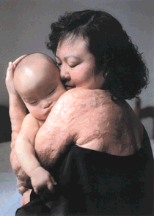
The other night, I saw again the TV documentary about the 9-year-old Vietnamese girl and others burnt by napalm and fleeing from a US air strike on their village in 1972. The incident was captured, just by chance, on film (shown) and made famous. The girl survived and now lives in Canada. Her back is still badly disfigured by the burns (shown). In the documentary, it shows her meeting the US officer who had ordered the raid believing, again from faulty intelligence, that there were no civilians in the village); he found out how wrong that was when he saw the photo in a US military newspaper the next morning.
That seems to be it for now.

Cheers

